(A) Deploy the Spring Boot Rest API into Microsoft Azure

1. login to Azure Portal and on the home page select App Services.

2. Then select on create App Service.

3. Open eclipse run following commands
mvn com.microsoft.azure:azure-webapp-maven-plugin:2.5.0:config

Then run the following command
mvn package azure-webapp:deploy
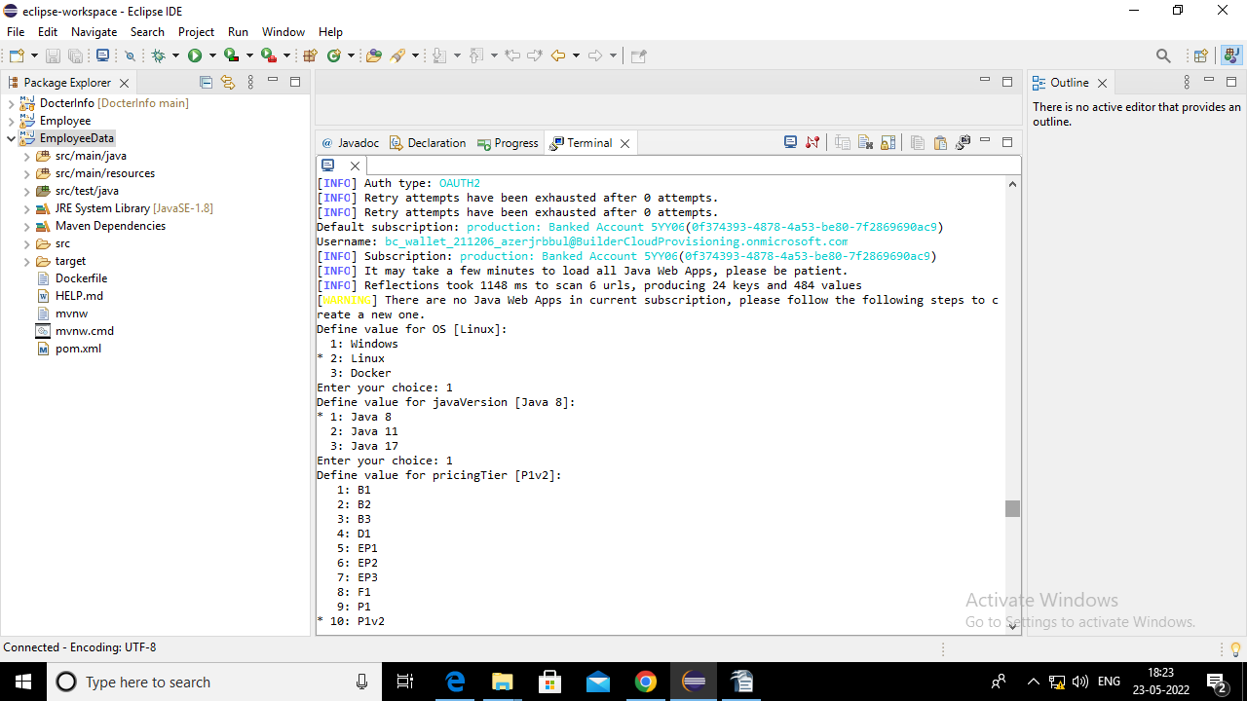
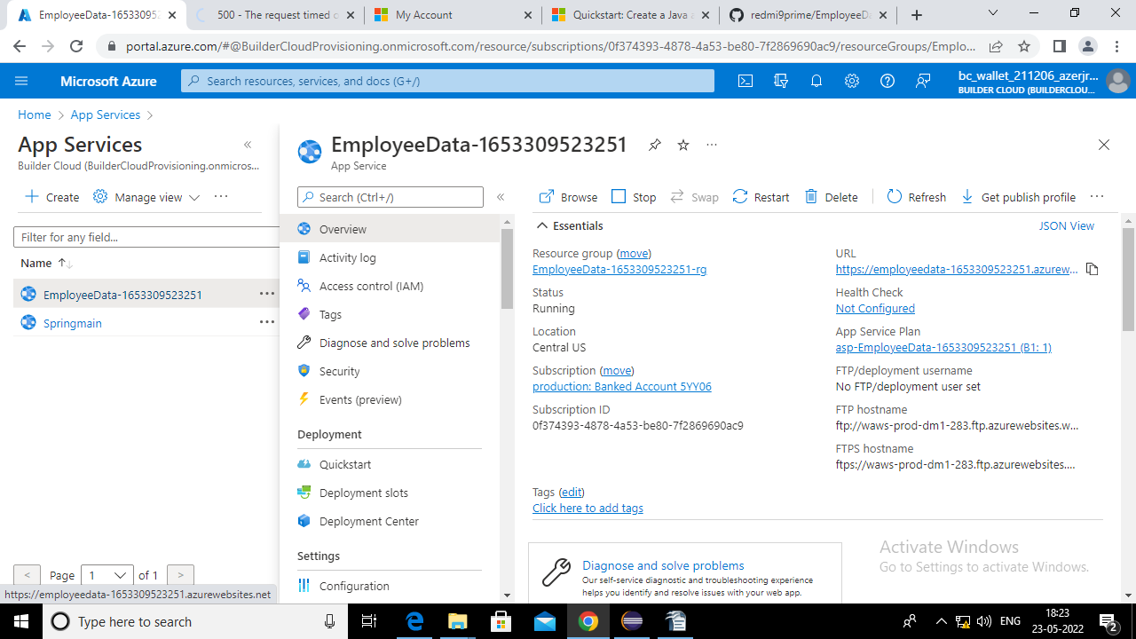

Deployed

